Time series observation is function of Trend, seasonality and irregular components. We study these components using below techniques

1. Decomposition method
2. Auto regression method

Smoothing techniques/Decomposition method:

1. Forecast by Moving avg
2. Forecast by Decomposition method (based on moving avg)
3. Forecast by Exponential smoothing
4. Moving Avg.

Can be used to smooth data to clearly see trend/seasonality (i.e. It will help understand overall pattern but nothing further)

Moving avg for forecasting: **- Cannot forecast well** and not recommended (See below) – using BY3H, BY9H

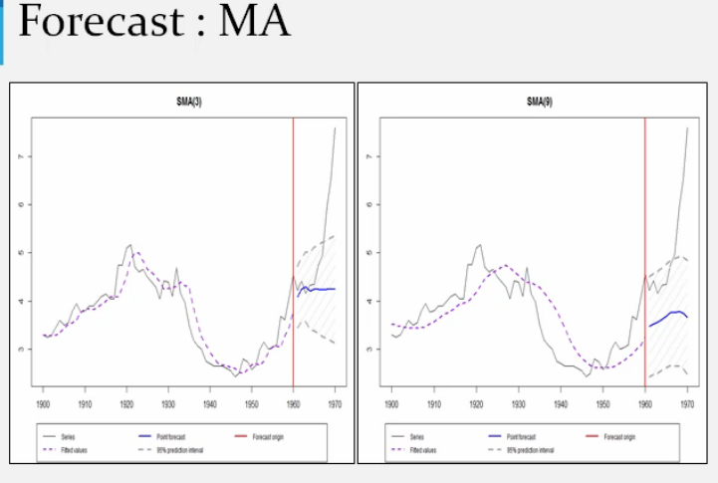

1. Decomposition method- (Use it to understand data (study trend seasonality etc) not recommended for forecasting)

Three classical data A) Seasonal only, B) Seasonality + Trend, c) Trend only

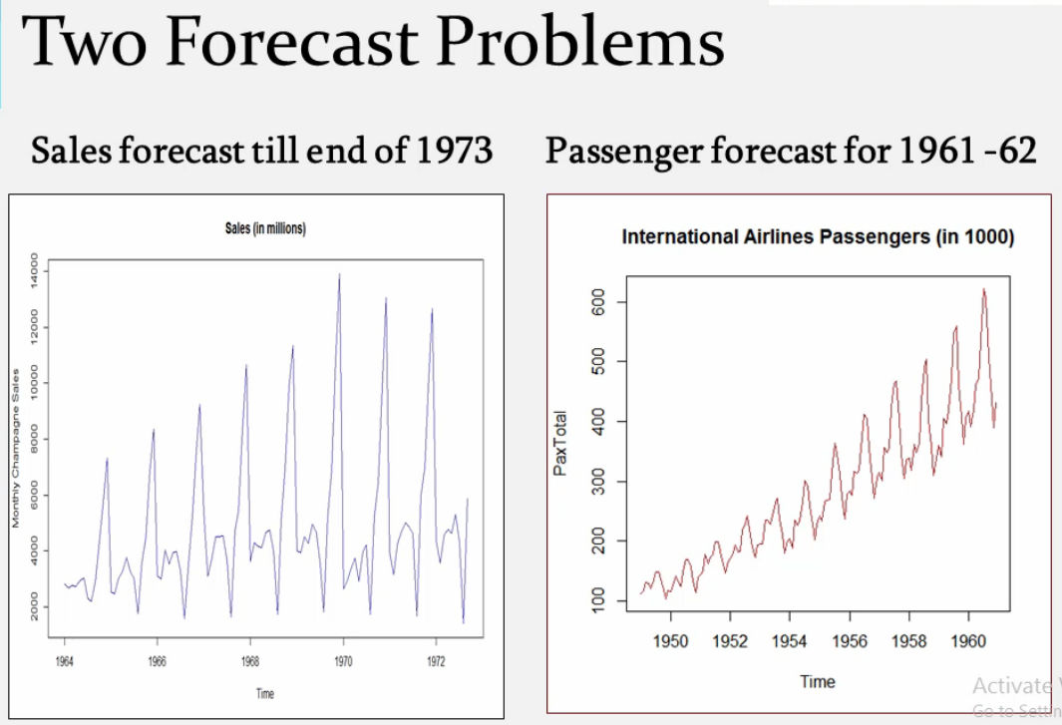

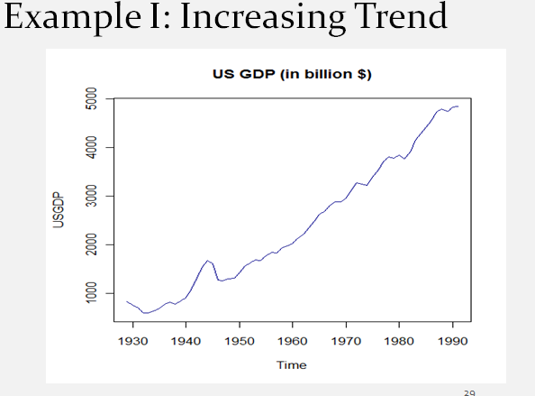

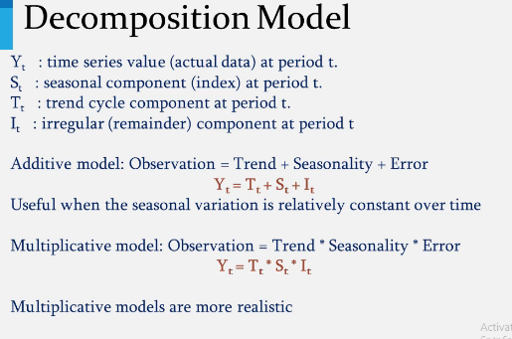

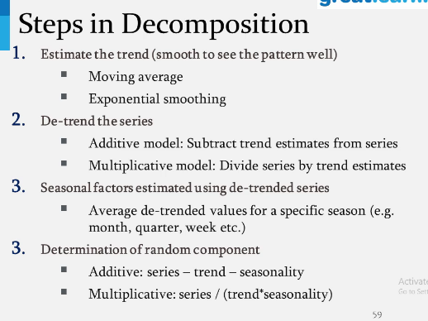

It decomposes every month's sales into Trend, seasonality and irregular component.

Use **decompose** R function with type(addative/multiplicative) as argument. (This assumes seasonality is constant throughout)

Whereas, using function **stl (Seasonal and trend decomposition using Loess)** dynamic technique - gradual change in seasonality as we move ahead can be controlled by parameter.

If trend increases – **fluctuation also increase** and then go for multiplicative model.

To plot different componenets –

AirP.multi <- decompose( data, type:"multiplicative")

1. Plot(AirP.multi$figure) == for seasonality
2. Plot(AirP.multi$trend) == for trend

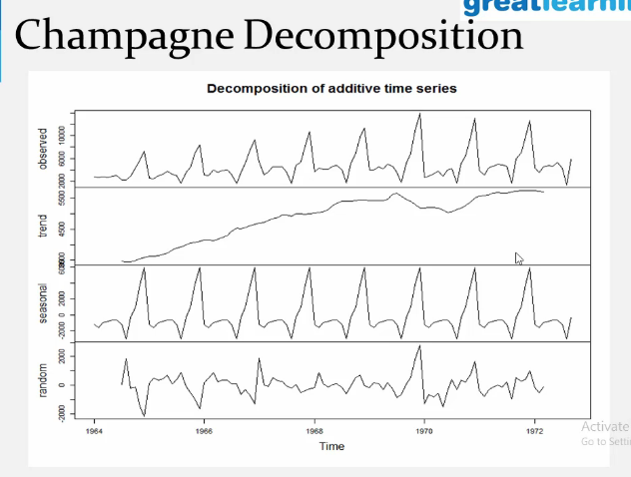

Seasonality is constant (when using decompose function)

**Forecast using stl function: (can be used for forecasting up to certain level)**

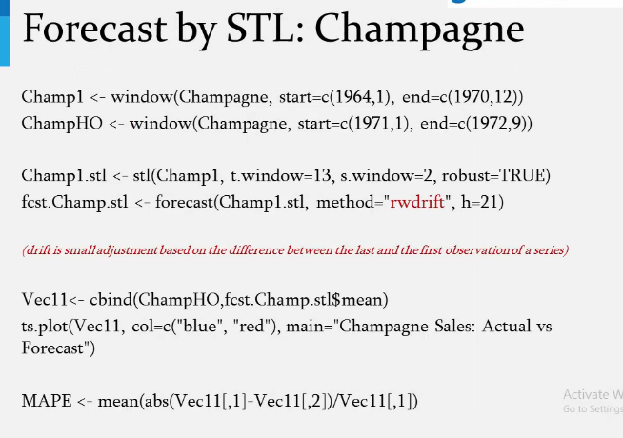

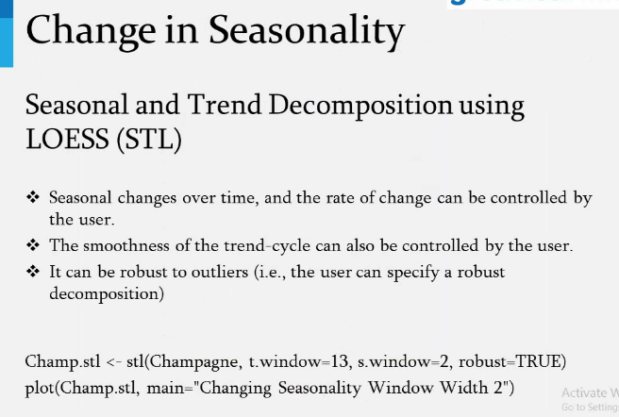

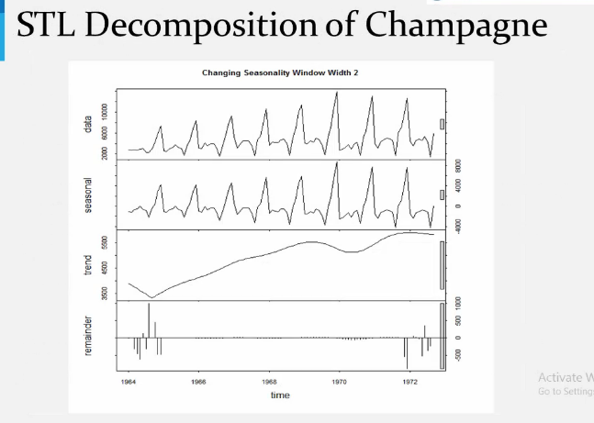

Limitation of STL : Works only for additive seasonal data and Cannot be applied directly if Data has multiplicative seasonality (Air passenger e.g.) - use log ( helps transform multiplicative to additive and variance stabilization)

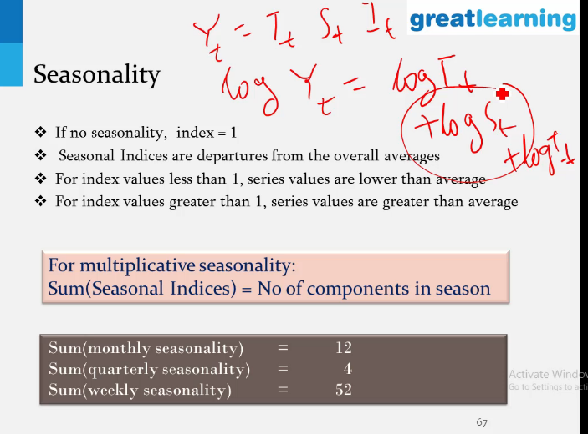

1. Exponential smoothing – (use it for forecasting)

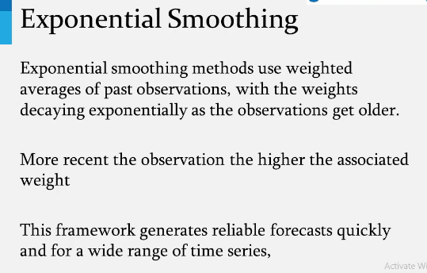

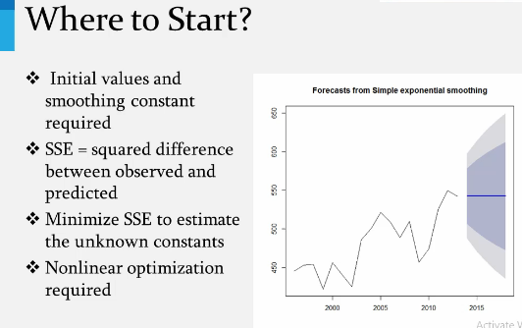

(R Library – fpp2)

1. Simple Exponential smoothing – (no – trend & seasonality) – random/flat

Only alpha – irregularity (Level)

No trend, No seasonality -🡪 Go for simple exponential model (only alpha)

(This method more like avg only) -----------(R command : ses)

1. Double exponential smoothing : If there is only trend then (2 degree of smoothing)

Alpha – irregularity

Beta – trend value

Only trend --🡪 Go for Double exponential model (alpha + Beta)

-----------(R command : holt)

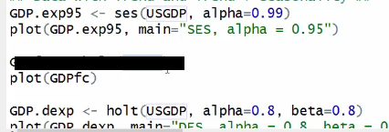

1. Triple exponential smoothing/ Three component/ Seasonal exponential smoothing (Holt winters model)(3 degrees of smoothing)

Alpha – irregularity (Level)

Beta – trend value

Gamma – seasonality

Trend + Season🡪 Go for Triple exponential model (Alpha + beta + gamma) Holt winter model

-----------(R command : hw)

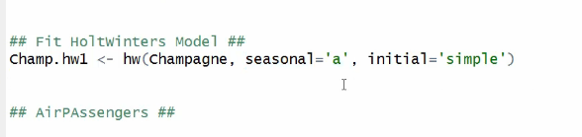

Next step out of decomposition is - **exponential smoothing with seasonality**

**(No limitation of Additive only or multiplicative only – works for all) - but setting alpha, beta and gamma combination needs expertise.(Trial and error)**

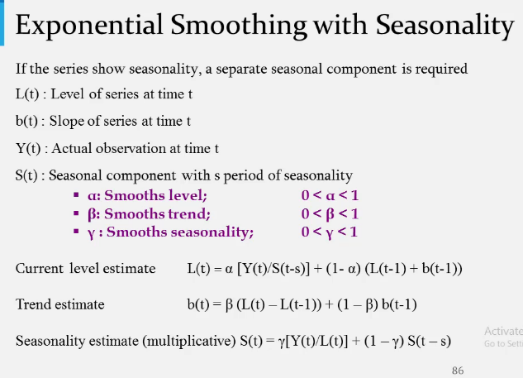

**Auto regression:**

1. ARIMA.Autofit – to get initial values of p(autoregression terms-mostly 1 or 2), d(degree of diff to make series stationar – 1 or 2), q(no. of moving avg. terms)
2. Fine tune build final model using ARIMA
3. Check AIC, sigma square and Box Ljung test (to test residual stationary hypothesis Ho – Stationary, H1 – nonstationary) and choose best model